1. In last lecture, we learnt how to pass and retrieve **route parameters**.
2. There are more things that can be attached to route such as
   1. **Query Parameters**:  
      
   2. **Hash Fragment**:  
      
3. Let’s see how to pass **query parameters** and **hash fragment** using **routerLink** or navigate().
   1. 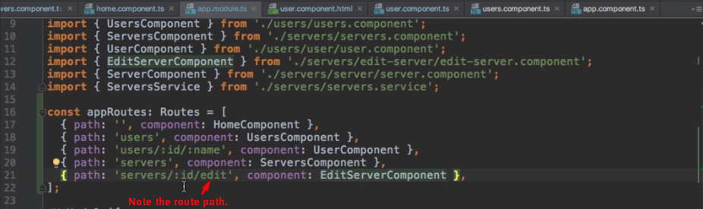
   2. 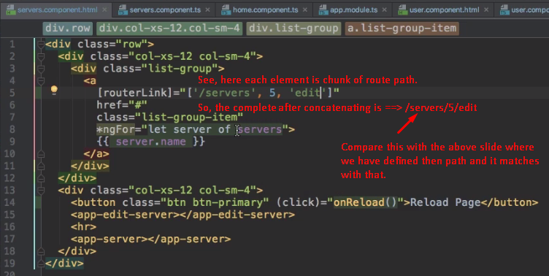
   3. To add query parameters to the route, we use **bindable property** of **routeLink** directive which is **queryParams**. 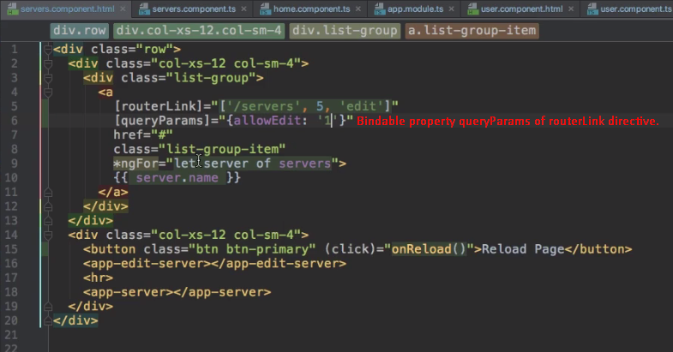  
      **Adding fragment**: 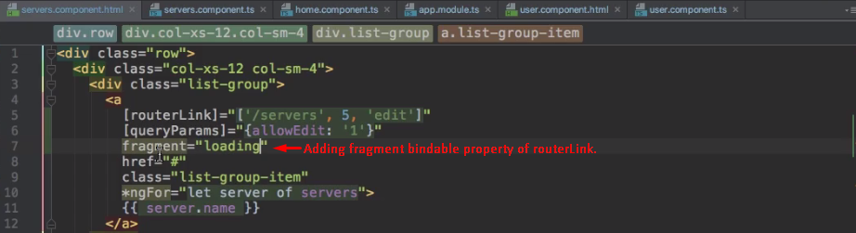
4. Let’s add the query parameters and hash fragment dynamically using ActivatedRoute.navigate();
   1. 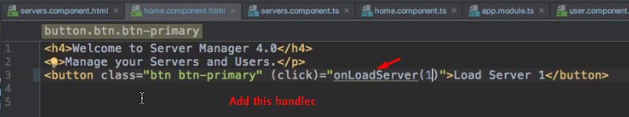
   2. 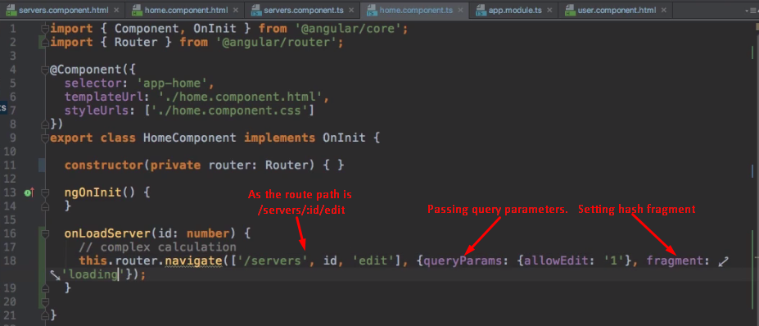
   3. 